Lab Assignment 3
Task 1: write a function to calculate compound interest, starting with only the function name
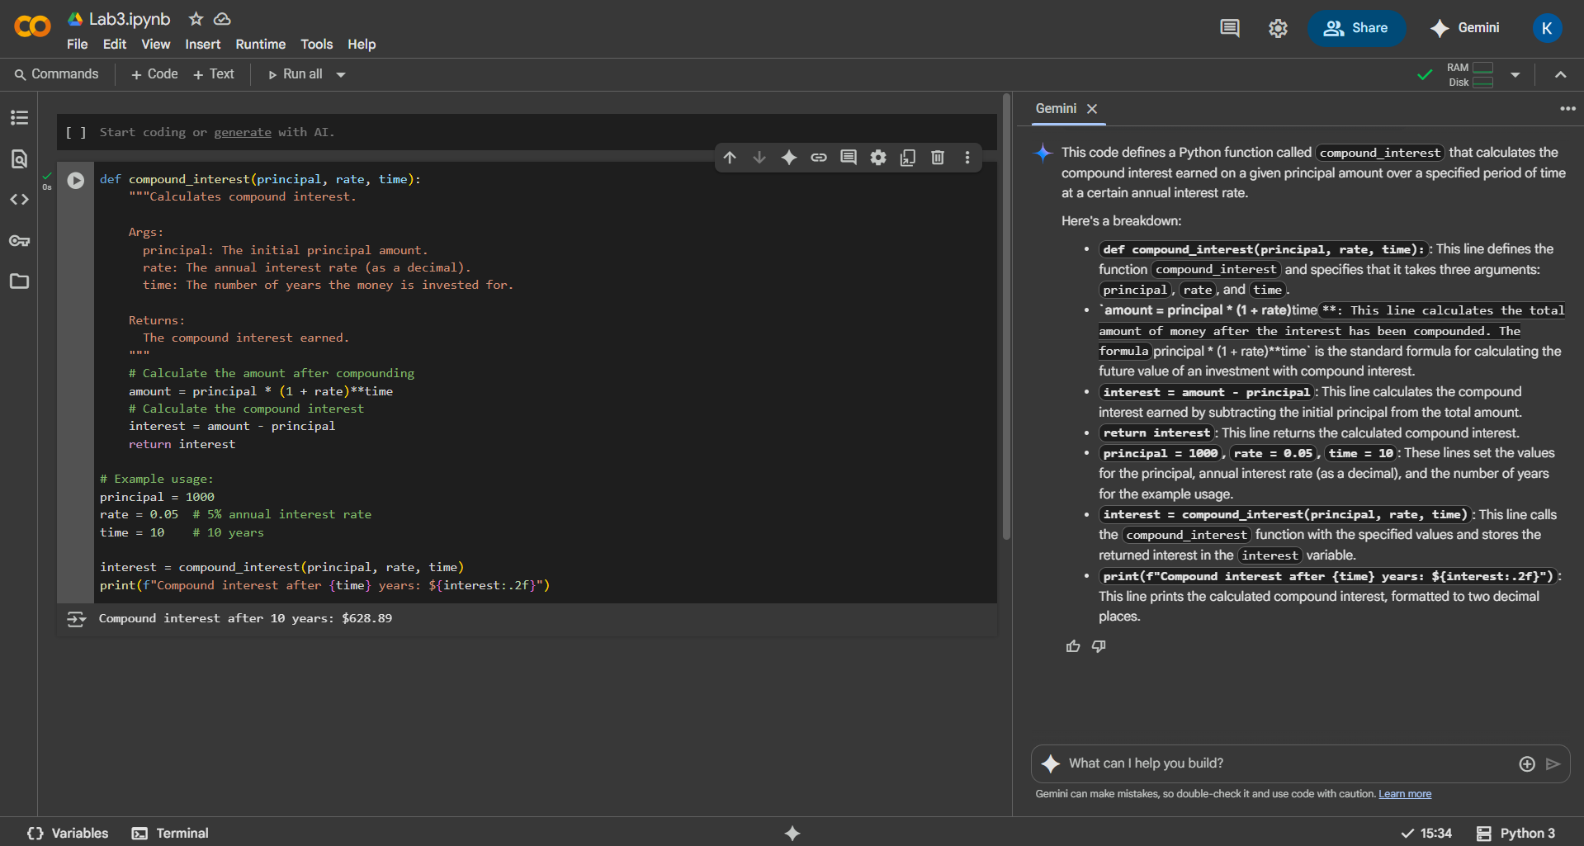

Task 2: Write a function to calculate average, median, and mode of a list of numbers
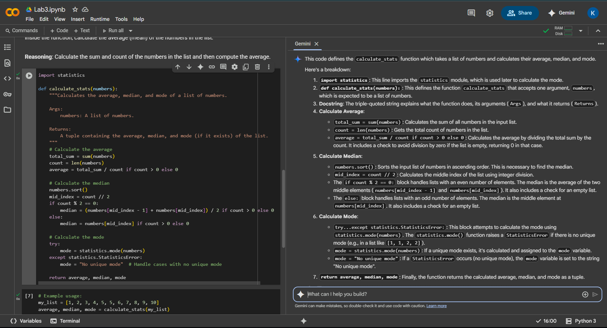
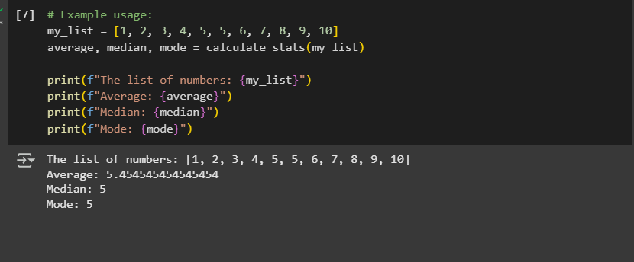

Task 3: Provide multiple examples of input-output to the AI for convert to binary (num) function
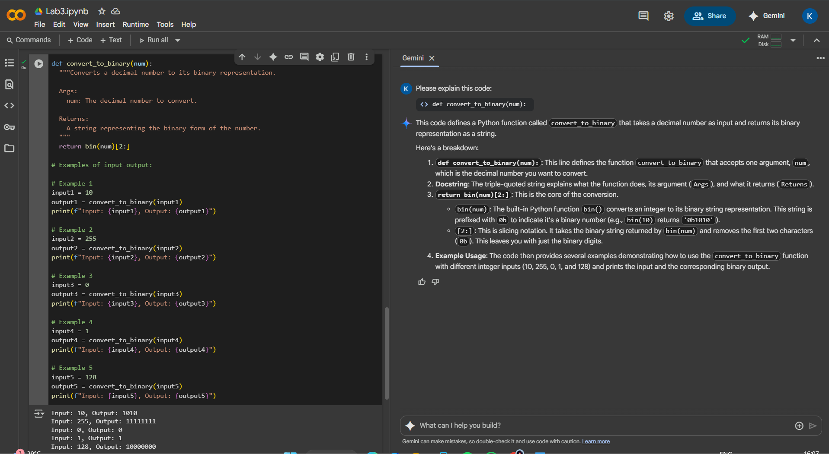

Task 4: Create an user interface for an hotel to generate bill based on customer requirements

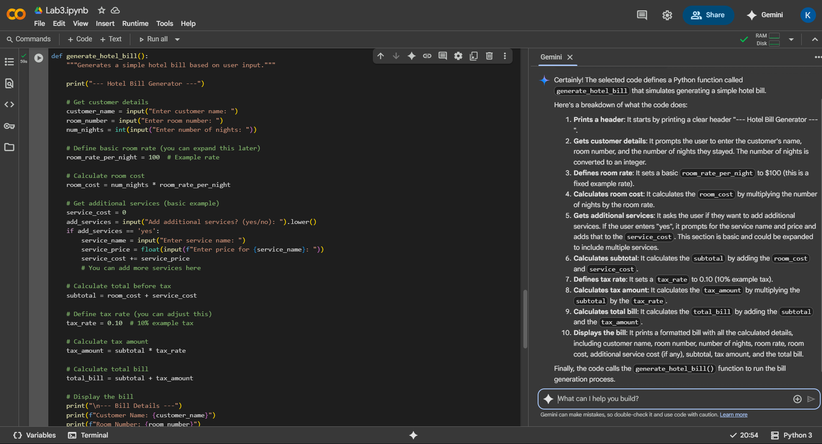
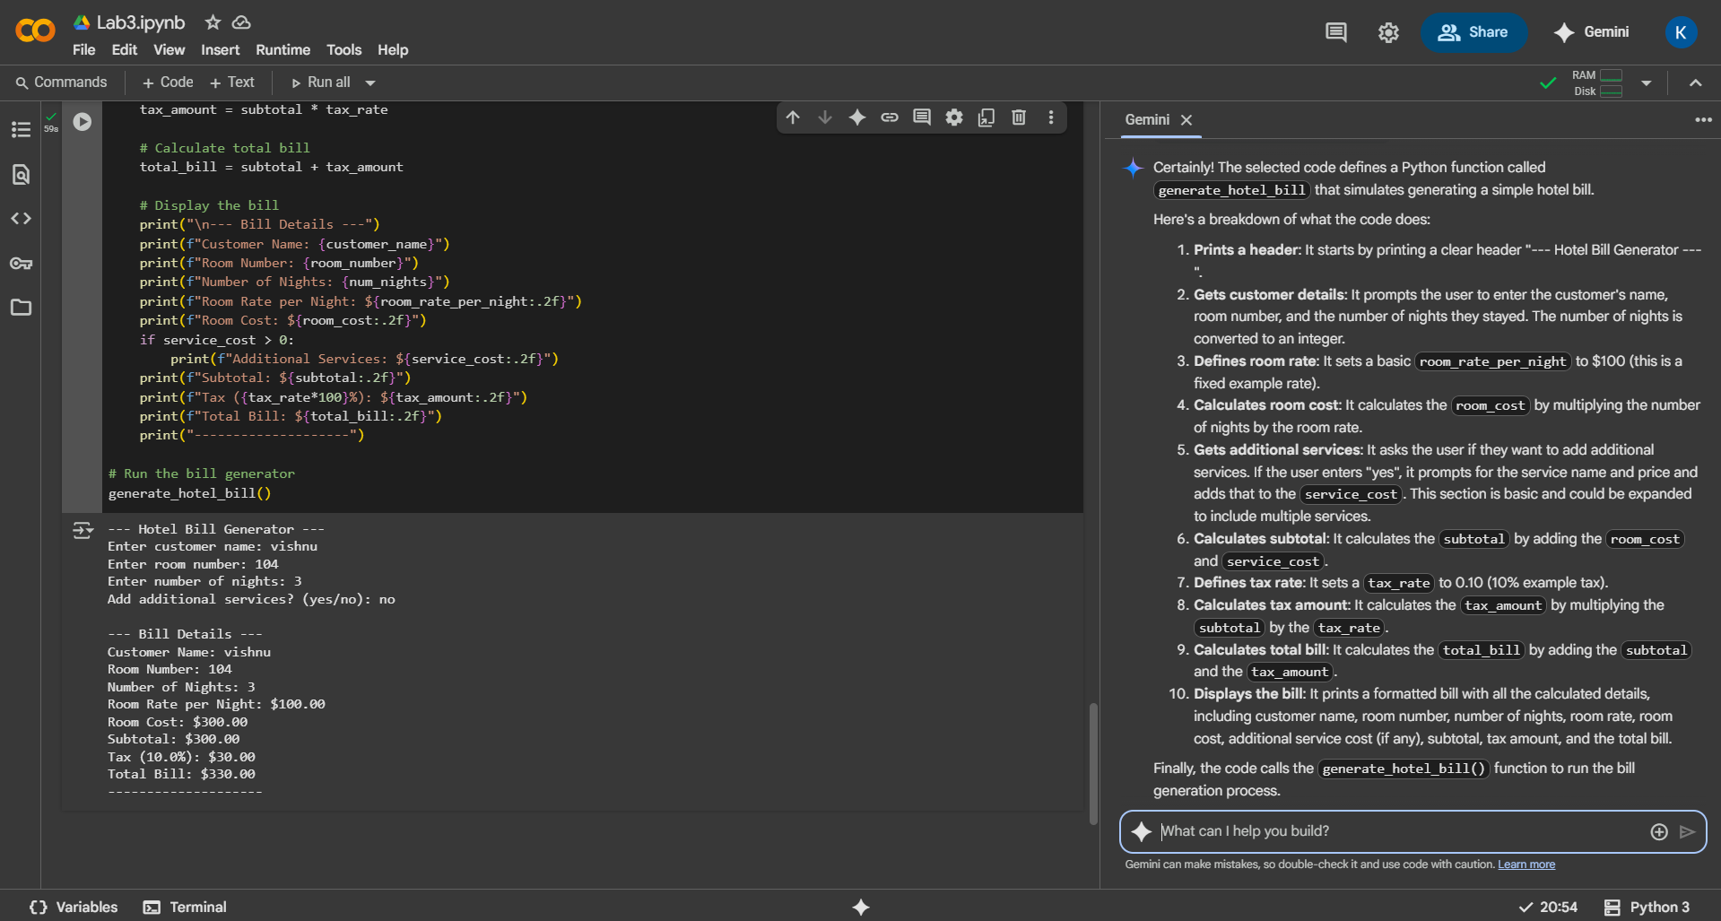

Task 5: Improving Temperature Conversion Function with Clear Instructions
